**Learning python programming using strings**

Kevin Karanja Wachira

Naivasha,2023

**Purpose:**

* To be able to access specific characters in string
* To be able to understand more characteristics of strings in python
* To be able to convert string to other dara types e.g lists and sets

**Theory:**

String is a collection of alphabets, words or other characters. Python has a built-in string class named str . Python strings are "immutable" which means they cannot be changed after they are created.

Strings in python are surrounded by either single quotation marks, or double quotation marks.

Strings in python are surrounded by either single quotation marks, or double quotation marks. Since strings are arrays, we can loop through the characters in a string, with a for loop. You can return a range of characters by using the slice syntax.

Specify the start index and the end index, separated by a colon, to return a part of the string.

Python has a set of built-in methods that you can use on strings.

**Task:**

Determine whether there are words in a given string whose sets of characters are equal. If found print these words on the screen.

**Solution:**

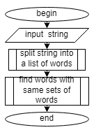

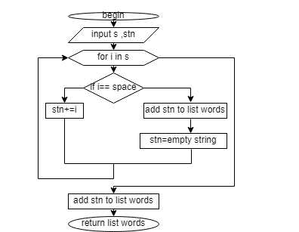

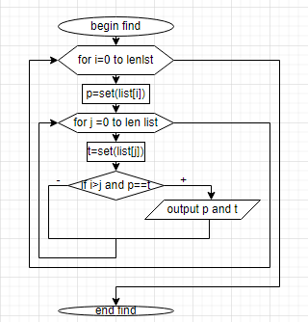

**Code:**

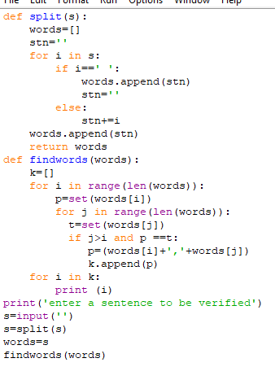

**Test Data:**

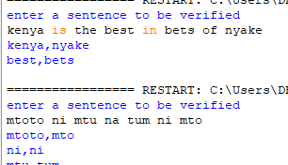

**Conclusion:**

strings in Python are arrays of bytes representing unicode characters. However, Python does not have a character data type, a single character is simply a string with a length of 1.